Year 1 and 2
Text types for the term: | Term: | Genre type: | Grammar targets:  Year 1: Year 2:
Supertato  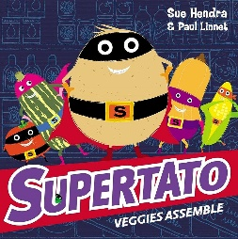  The little red elf  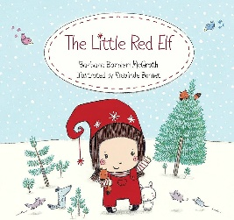 | 1 | Fiction  Narrative.  Character description. | T1  Demarcate most sentences using a capital letter and full stop.*. | T1  Use full stops and capital letters consistently.*
 | 1 | Non-Fiction  Explanation- Supertato’s new super outfit. | T2  Use the names of people, places and things | T3  Use commas in a list.
 | 2 | Narrative  Instructions- new toy | T3  Join words using ‘and’.  T4  Use ‘and’ to join simple sentences. | T2  Add –er, -est, -ing nd –ed when there is no change in spelling of the root word.  T4  Use co-ordination (and, or, but, so) *
 | 2 | Narrative  Instructions- new toy | T5  Identify proper nouns | T5  Use simple expanded noun phrases to describe and specify
Zog and the doctors  Kassim and the Greedy dragon. | 3 | Fiction- | T6  Use a capital letter for names of people, places, days of the week and the person pronoun ‘I’. | T6  Use a variety of simple pronouns (her, she, the girl, Lucy)  T7  Use subordination (when, if, because, as)*
Zog and the doctors  Kassim and the Greedy dragon. | 3 | Non-Fiction-letter to the king persuading why the princess should be a doctor. | T7  Begin to use ‘because’ to join ideas. | T8  Use sentences of different forms: questions (Correct use of question mark)*  T9  Use the present and past sentences accurately (consistently)*
Zog and the doctors  Kassim and the Greedy dragon. | 4 | Fiction- warning tale | T8  Begin to demarcate sentences with a question mark | T10  Use exclamation marks as an indication to the reader
Zog and the doctors  Kassim and the Greedy dragon. | 4 | Non-Fiction- information text about dragons | T9  Use the past and present and past tenses accurately (generally) | T11  Use sentences with different forms: statements and commands
Malala’s magic pencil  One day on our blue planet in the savannah.  Handa’s surprise | 5 | Fiction  Narrative – Fantasy story. | T10  Begin to demarcate sentences using an exclamation mark | T12  Use sentences with different forms: exclamations
 | 5 | Non-Fiction  Diary | T11  Write sequenced or linked sentences | T13  Use the progressive form of verbs
 | 6 | Fiction  Non chron report African animal | T12  Sequence short sentences to write short texts | T14  Use apostrophes for contraction  T16  Use apostrophes for singular possession.
 | 6 | Non-Fiction  Handa’s surprise- recount linked to art day. | T13  Add –er, -est, -ing and –ed when there is no change in spelling of the root word. | T15  Use a variety of simple, compound and complex sentences (co-ordinating and subordinating conjunctions)

Year 3
Text types for the term: | Term: | Genre type: | Grammar targets:  Year 3:
Main text:  Paddington  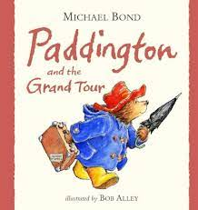  The monster health book.  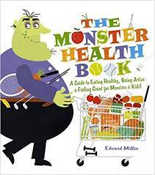  Digestive system poetry. | 1 | Letter | -Full stops, capital letters, question marks, exclamation marks  -Noun phrases  -Use simple conjunctions ‘and’ ‘because’ ‘so’
 | 1 | Narrative- adventure | -Noun phrases  -Prepositions of place
 | 2 | Non Chron report | -Headings and subheadings  -Use ‘a’ or ‘an’ correctly.  -Compound and complex
 | 2 | Poetry | -Simple and progressive tenses
Main text:  The long lost secret diary of the world’s worst tomb Hunter.  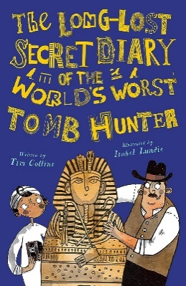  BFG  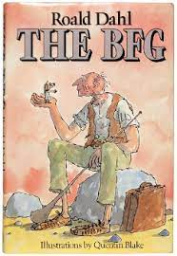 | 3 | Diary | -Paragraphs-Nouns and pronouns to aid cohesion  -Apostrophes for contraction and singular possession
 | 3 | Newspaper | -Commas in a list  -Speech  Use a range of adverbs, conjunctions and prepositions for time e.g. later, next, soon, while, suddenly, now
 | 4 | Narrative- fantasy | -Noun phrases  --Speech
 | 4 | Explanation- instructions. | -Use a range of co-ordinating conjunctions accurately and effectively.  -Compound and complex sentences  -Cause conjunctions
Main text:  Peter Pan  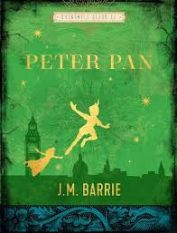  The magic box poem.  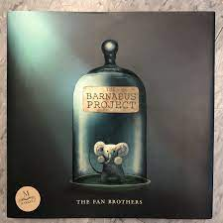 | 5 | Recount | -Use a range of adverbs, conjunctions and prepositions for time e.g. later, next, soon, while, suddenly, now  -Commas in a list
 | 5 | Advert | -Present perfect
 | 6 | Poetry
 | 6 | Narrative | -Present perfect  -Speech

Year 4
Text types for the term: | Term: | Genre type: | Grammar targets:  Year 4:
Main text:  Marcy and the Riddle of the Sphinx.  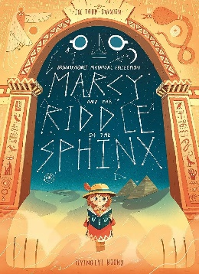  The lion the witch and the wardrobe.  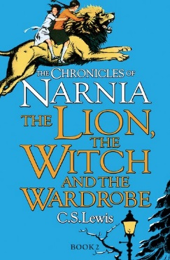 | 1 | Setting description | -Fronted adverbials  -Noun phrases
 | 1 | Letter | -Noun phrases/ figurative language  -Coordinating conjunctions
 | 2 | Narrative- fantasy | - Compound and complex  -Speech
 | 2 | Poetry | -Past tense
Main text:  The long lost secret diary of the worlds worst Olympic athlete.  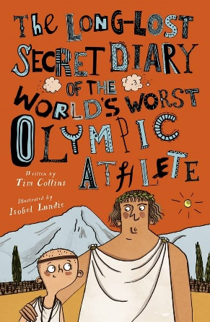  The Iron Man Poem  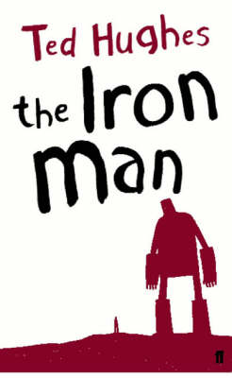 | 3 | Diary | Paragraphs -Nouns and pronouns to aid cohesion  -Plural possession  -Possessive pronouns
 | 3 | Newspaper | - Use a wider range of conjunctions to extend the range of complex sentences
 | 4 | Poetry | -Noun phrases/ figurative language  - Use noun phrases expanded using modifying nouns
 | 4 | Non chronological report. | -Compound and complex sentences  -Speech
Main text:  How to train your dragon.  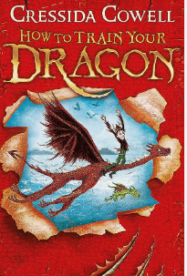  Holiday adverts. | 5 | Narrative adventure | -Use noun phrases expanded using prepositional phrases  -Commas correctly used after fronted adverbials
 | 5 | Dragon explanation | - Present tense
 | 6 |  | -Speech  -Describe characters through show not tell (inference)
 | 6 | Advert- Holiday to China | - Present tense

Year 5 and 6
Text types for term: | Term: | Genre type: | Grammar targets:  Year 5:
Main Text  Beowulf, Grendel and the dragon  Poetry: Beowulf  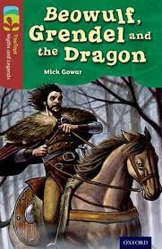Picture Books:  Journey  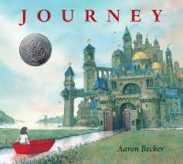  Narrative: Ice Trap  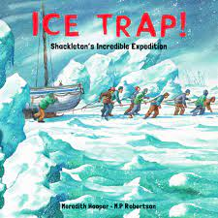  Shackelton’s Journey by William Gill  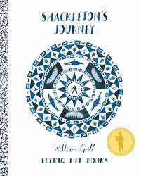 | 1 | Campaign Speech | T1  Revise noun phrases expanded using modifying adjectives, nouns and prepositional phrases
 | 1 | Narrative | T2  Use commas to separate main and subordinate clauses (when subordinate clause is at the start)  T3  Indicate degrees of possibility through use of modal verbs
 | 2 | Poetry | Revisit 1, 2, 3  T4  Indicate degrees of possibility through use of modal verbs
 | 2 | Diary | T5 Indicate degree of possibility through the use of adverbs (perhaps, surely, possibly)
Main Text  Kensuke’s Kingdom  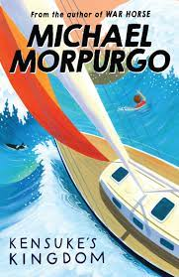  Poetry  The Highwayman  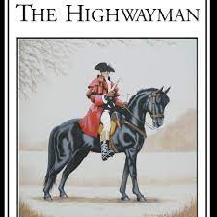  Stormbreaker  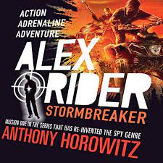  Tourism Persuasive Adverts | 3 | Recount  Narrative | Revisit 1 - 5  T6  Use a range of cohesive devices within paragraphs (repetition, pronoun choices, adverbs & adverbials, tense choice, pronoun agreement etc.)
 | 3 |  | T7  Use a range of cohesive devices to link between paragraphs
 | 4 | Formal letter  explanation | T8  Use relative clauses beginning with who, which, where, when, whose and that.
 | 4 | Persuasive advert Newspaper | T9  Use inverted commas and other punctuation to indicate direct and reported speech.
Main Text The House With Chicken Legs  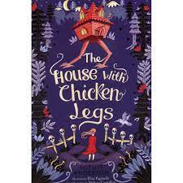  Poetry: The house on chicken legs by Stephanie Pratt  Henry’s Freedom Box  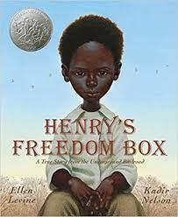  Freedom  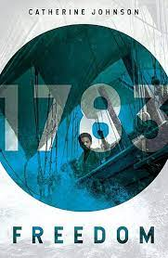  Hidden Figures  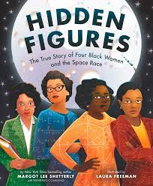 | 5 | Narrative – different character | T10  Use brackets and dashes for parenthesis
 | 5 | Discussion  Diary | T11  Use embedded clauses (relative and subordinate)
 | 6 | Information – non chronological | T12  Use a range of verb forms (simple, progressive, perfect, modal) appropriately.
 | 6 | Poetry  Biography | Recap

Year 6
Text types for term: | Term: | Genre type: | Grammar targets: Year 6:
Street Child  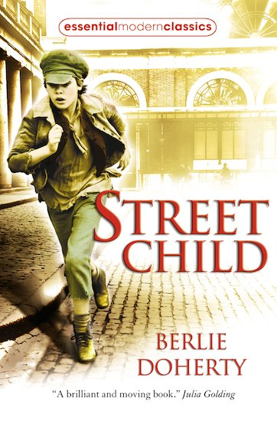  The Lost words  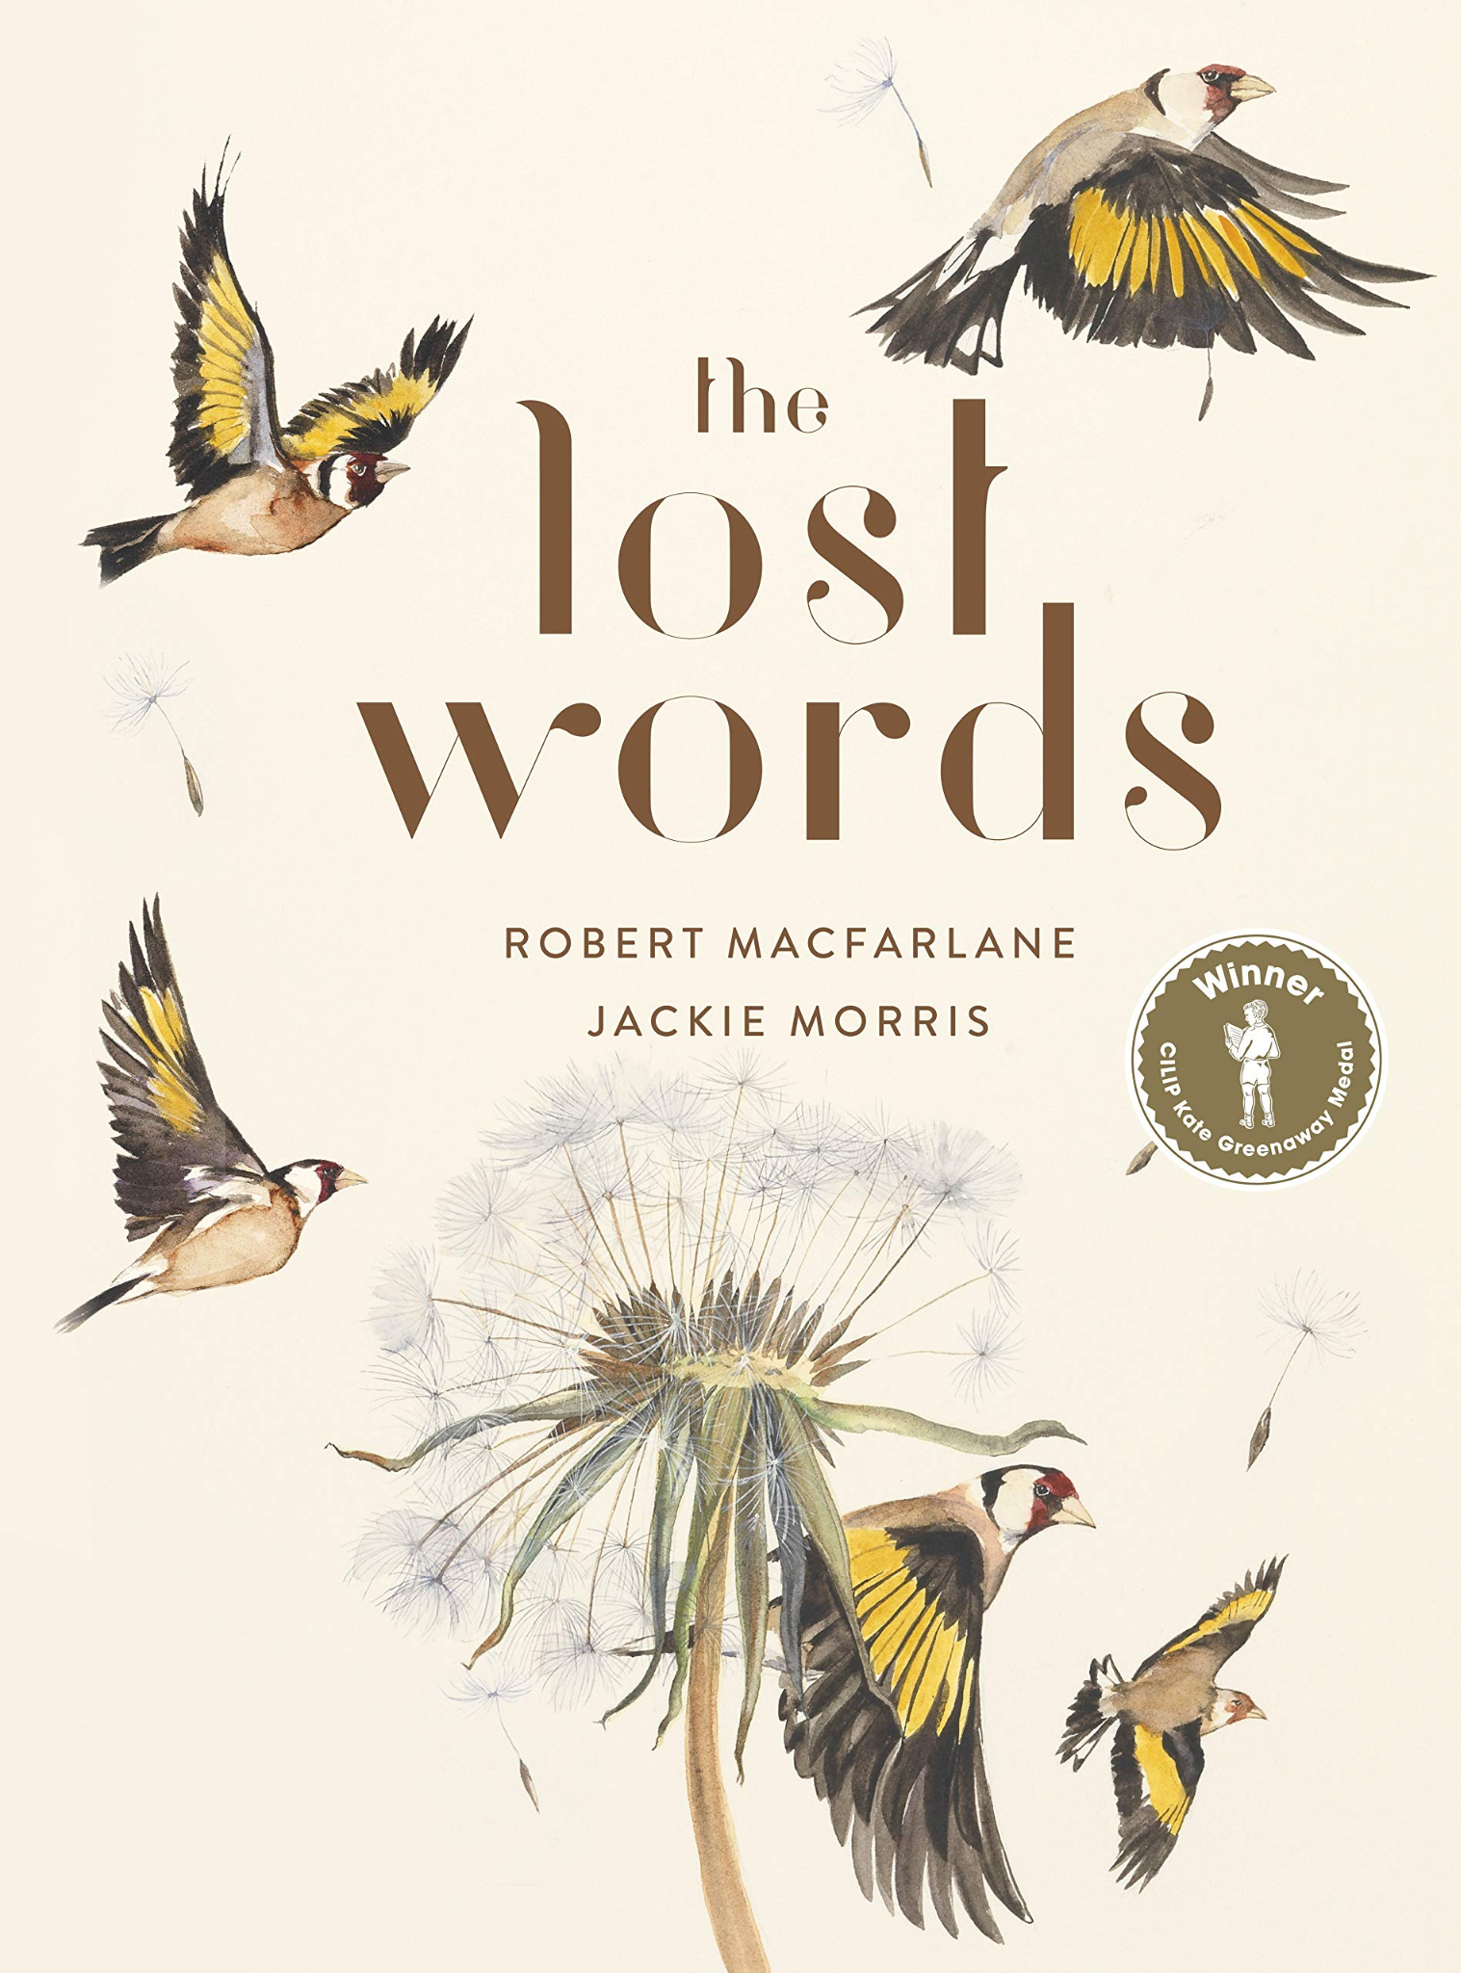  Varmints  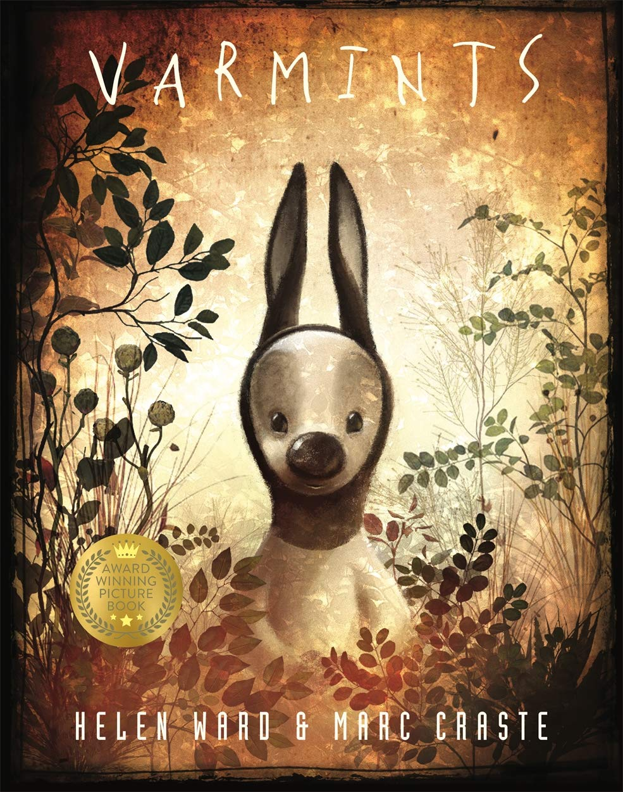  The Nowhere Emporium  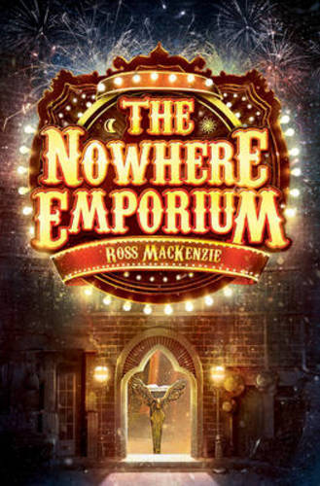 | 1 | Campaign Speech | T1  Use expanded noun phrases across writing to convey complicated information concisely.
 | 1 | Narrative | T2 Use a range of simple, compound and complex sentence structures.  and T3 Use hyphens to avoid ambiguity.
 | 2 | Poetry | Revisit 1, 2, 3  T4 Relative clause
 | 2 | Diary  Narrative – setting  Narrative - Character description | T5  Use dashes for afterthoughts  Use dashes for parenthesis
Letters from the Lighthouse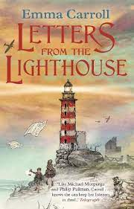  Newspapers  Propaganda WW2  The Declaration  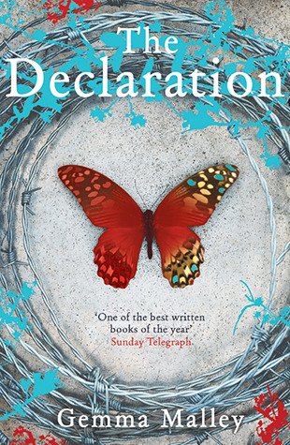  The Jabberwocky | 3 | Suspense narrative  Biography  Recount | Revisit 1 - 5  T6  Link ideas within and across paragraphs using a range of cohesive devices (repetition, range of adverbials, ellipsis, referencing etc.)
 | 3 | Suspense narrative  Biography  Recount | T7  Write with the appropriate levels of formality for the audience and purpose.
 | 4 | Formal letter  explanation | T8  Use relative clauses beginning with who, which, where, when, whose and that.
 | 4 | Persuasive advert Newspaper  Argument | T9  Use passive voice to create empathy, suspense and a formal tone.  T10  Use formal and informal question tags
The Declaration continued  Holes  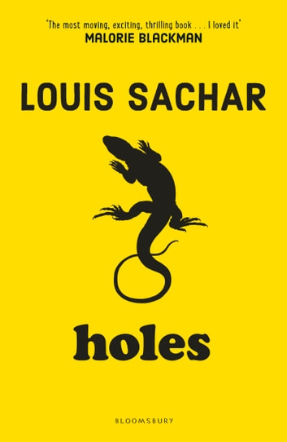 | 5 | Narrative – different character | T11  Use a multi-clause sentence (controlled use of)
 | 5 | Discussion – balanced argument  Diary | T12  Use a range of verb forms for effect. (His distraught mother, blames herself: ‘If only I had asked him more about it; maybe I could have stopped him from using it. I would never have let him go to that awful dump if I’d known this would happen. Now he’s been taken from us and we don’t know what to do.  T13  Use the subjunctive
 | 6 | Information – non chronological
 | 6 | Poetry  Biography | Recap all

